As discussed, here is the marketing template order form. Simply check the items you would like and our marketing department will prepare the items for you. There are four actions to take:

1. Fill out the information
2. Select the type of pieces
3. Select a theme
4. Attach a high-resolution logo (300 dpi png, jpg or gif) when you email order form back to me

**STEP 1 Provide the following info:**

Type the business name as you want it to appear on the templates:

Type the website address that you want to direct customers to:      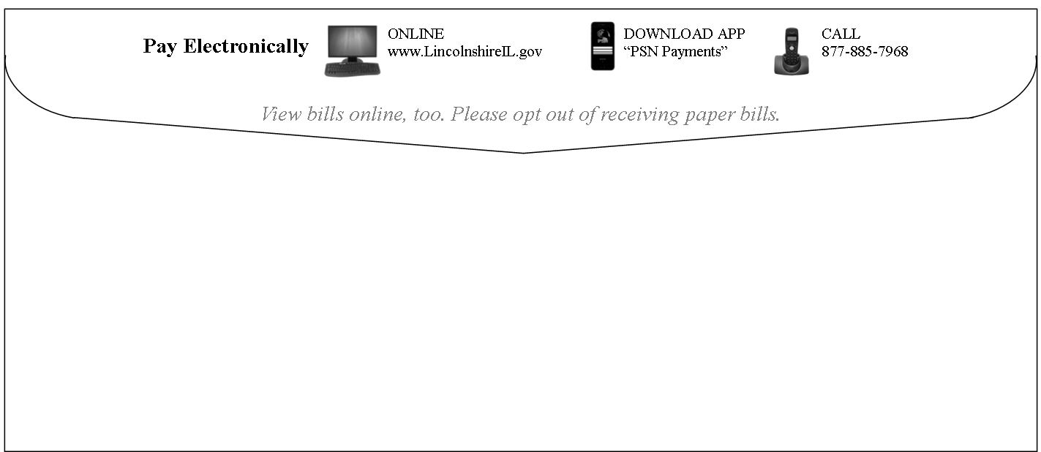

Are you submitting a high-resolution logo to add to the templates: Yes No

If you use billing envelopes, do you want us to provide icons and messages for you to provide your printer? Yes No NA

Or would you like us to work directly with your printer? Yes No NA   
 (provide name/contact info of printer)

The **MOST EFFECTIVE** and generally **NO COST** method of informing customers is to have electronic payment info printed on the flaps of envelopes. PSN can work with you or your printer to make this happen! Just call us. 

**STEP 2 Select the type of templates you would like by checking the box.**

|  |  |  |  |  |
| --- | --- | --- | --- | --- |
| **Poster** | **Tear-off Poster** | **Handout or Full-page Stuffer** | **Bill Stuffers (3-up)** | **Postcard** |
|  |  |  |  |  |
| poster pay only.png | tags.png | handout pay only.png | 3-up mom.png | Utility Postcard-bill-tech.png |
| **Business Cards**  **(10-up)** | **Mini Handouts  (8-up)** | **Press Release** | **Customer Letter** | **Facebook Posts** | **Email** |
|  |  |  |  |  |  |
| Business Card.png | minis.png | Utility PRESS RELEASE-ebills1_Page_1.png | Letter for Customer - multiple depts.png |  |  |

**STEP 3 Select a theme(s). You can select 1 or 2 images. Check the box ABOVE the images you want to use.**

|  |  |  |  |  |
| --- | --- | --- | --- | --- |
| **TECHNOLOGY** | **GREEN** | **NO MORE CHECKS** | **MOBILE** | **WHIMSICAL** |
| Electronics cut our hi-res.png  A    C  Laptop Typing iStock_000035693428.jpg | Green globe tree.png  A    B  C  Green Hands Tree.jpgtree knocked out.png | check photo.jpg | man texting.jpg  A      C  B  woman texting.jpgTablet City Background iStock_000048607634.jpg | feet.jpgBeach Scene.jpg    A  B    C    D  123 poster.pngPay online button.jpg |
| **CREDIT CARD** | **PARENT WITH CHILD** | **FAMILY**  A | **YOUNG COUPLES** | **SENIORS** |
| Mobile Payment iStock_000057977984.jpg  A    C  B    Man Couch Phone iStock_000046185270.jpgwoman vertical.jpg | mom.jpg  A  C    B  couple in kitchen vertical.jpgfather-son istock Rich Vintage.jpg | family with computer vertical.jpg  C    Family white.jpg    Family white.jpg  D | A      B  Home Page Payment Solutions.jpg  C    couple laptop square.jpg | senior couple crop.jpg |

**STEP 4 Save this form; email it back to your Service Account Manager; attach a high-resolution logo (if available).**