Plan to Inform Customers on How to Pay Utilities

Paying utilities online or by phone is a great convenience for customers, but more importantly, it can be of great benefit to you and your company. But customers won’t use the convenience unless they are informed—continually. We have created this marketing plan for you to follow to ease your workload and make sure customers are reminded constantly to use the payment services offered.

Use PSN **FREE** Marketing Services

Let the marketing staff at PSN do the work for you. At no charge, they can provide:

* **Website buttons** (to link from your site to PSN)
* **Website page mockup** to explain to customers how to make payments
* **Templates** for printing
  + Posters
  + Handouts (full page or multiples per page)
  + Stuffers
  + Envelopes
  + Letter to resident
* **Email notification** in html (PSN can even send the notice out for you—there is a small fee for sending the email)
* **Press release** (for your newsletter or local paper)

Tips…

Those who have experienced success have provided these suggestions:

* Create a theme for your marketing pieces that reflects your customers’ tastes
* Change the theme occasionally to get freshly noticed (PSN can provide new pieces)
* Use different methods to inform residents (email, handouts, stuffers, posters, verbal)
* Request emails on customer applications
* Train your new staff about PSN services and carrying out the marketing efforts
* Set goals for how many customers you want to pay through PSN and celebrate when you achieve your milestones

The **MOST EFFECTIVE** and generally **NO COST** method of informing customers is to have electronic payment info printed on the flaps of envelopes. PSN can work with your printer to make this happen! Just call us.

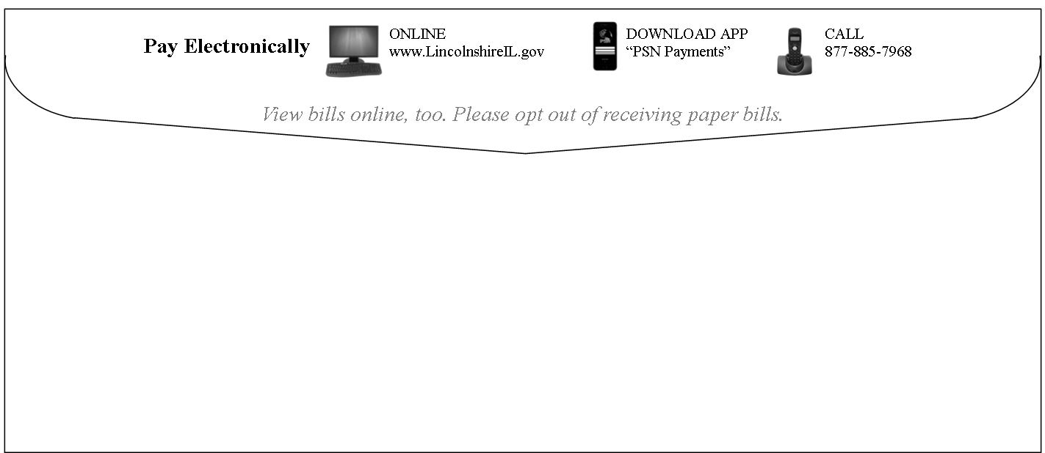Year: ______ (Copy this chart for subsequent years.)

|  |  |
| --- | --- |
| Task | Date Executed |
| New Service Packet/Information | |
| Create a full-page handout on how to pay utilities and add to new service packet/information |  |
| Website | |
| Add a prominent link to your website **home page**; you can also add an informational page explaining payment options |  |
| Customer Bills | |
| Add to all billing statements (including cut-off notices) a noticeable line about paying online |  |
| Billing Envelopes | |
| Add copy to envelopes (front & back) encouraging ePayments |  |
| Bill Stuffers (depending on billing cycle) | |
| Quarter 1: Stuffer with bill promoting paying electronically |  |
| Quarter 2: Stuffer with bill promoting paying electronically |  |
| Quarter 3: Stuffer with bill promoting paying electronically |  |
| Quarter 4: Stuffer with bill promoting paying electronically |  |
| Email Notification | |
| 1st notice informing customers how to pay online |  |
| 2nd reminder (you can run a report in PSN to see who is registered so that you don’t send notices to current users) (use new theme) |  |
| 3rd notice (reminder; use new theme) |  |
| Posters | |
| Place posters at all payment locations; replace occasionally to that get noticed |  |
| Handouts | |
| Place at payment counters |  |
| Continually replenish with new themes |  |
| Automated Calls to Residents | |
| For late payers, use PSN’s Auto-Call service wherein customers can press “1” to make a payment (fee-based service) |  |
| Customer Newsletters (if applicable) | |
| In each newsletter, remind residents to pay electronically |  |
| Press Release | |
| Send to all media—tv, radio, print) |  |
| Other Ideas (e.g., giveaways, contests) | |
|  |  |