ICON REQUEST
Name of business:
Requested by: Date needed: Click or tap to enter a date.
Email:
After downloading this form, you can right click on the images to copy and paste or to save to your computer. If you would like us to send you the icons, please check those you would like. The icons will be sent as low-resolution .png files which can only be used on websites or in emails. Email the form to your Service Account Manager.
Payment Method Icons
 |  |  | 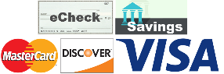
 | 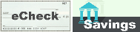 |  | 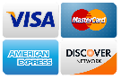
 | Other configurations, please specify:
NOTE: The app can only be used for one of your PSN accounts.*
NOTE: The app can only be used for one of your PSN accounts.*
NOTE: There are different phone numbers for the type of account
NOTE: There are different phone numbers for the type of account
Payment Channels
Utility w/ eBills  (software integrated) |  | Utility  (software integrated) |  | Rent |  | Other
 |  |  |  |  | 
 | 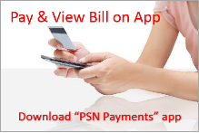 |  | 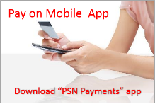 |  | 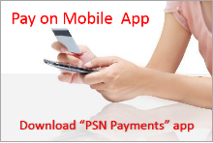
 |  |  |  |  |  |  | 
 |  |  | 
 | 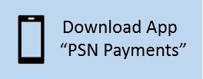
 | 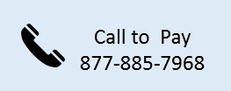 |  |  |  | 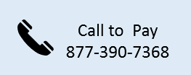 |  | 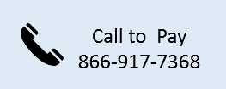
*If you have more than one PSN payment account, the app can only be promoted for one of the accounts. For examples: If you have utility and tax accounts, the app should only be promoted for utility payments. If you have rent and deposit accounts, the app should only be promoted for rent.
More icons on next page

Additional Icons
 |  |  |  |  | 
 |  |  |  |  | 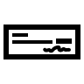 |  | 
 |  |  |  |  | 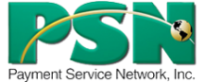

Additional Requests:
Don’t forget, our marketing department is here to help with adding info to your website.
If you have any questions, please contact your SAM who can request
assistance from our Marketing staff.

